Name: Paula Emad Shohdy

ID: 259

Group: 2

Section: 12

Github-link: https://github.com/PaulaShohdy/ece001

**Topic: Operating systems**

*Application brief:*

An operating system is the most important software that runs on a computer. It manages the computer's memory and processes, as well as all of its software and hardware. It also allows you to communicate with the computer without knowing how to speak the computer's language. Without an operating system, a computer is useless. The three most common operating systems for personal computers are Microsoft Windows, macOS, and Linux. Mobile devices such as phones, tablet computers, and MP3 players are different from desktop and laptop computers, so they run operating systems that are designed specifically for mobile devices. Examples of mobile operating systems include Apple iOS and Google Android.

***Screenshots:***

***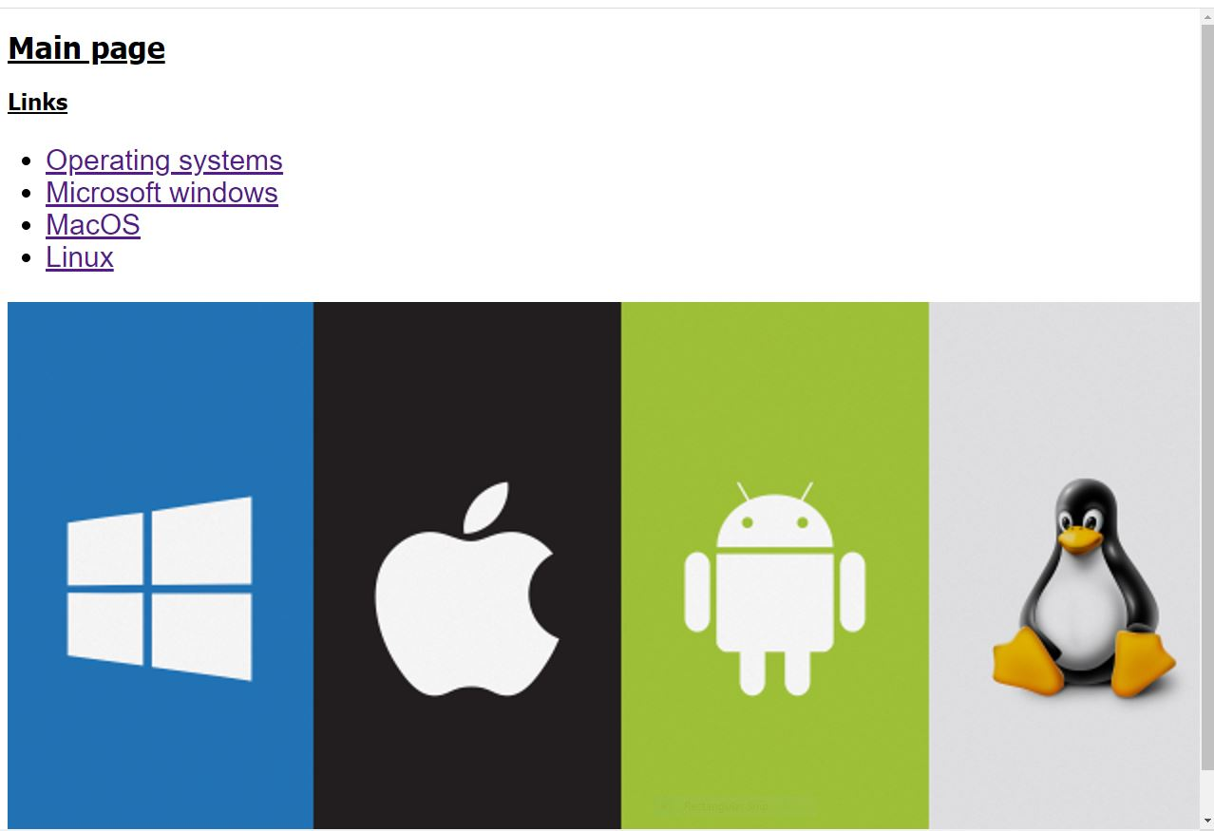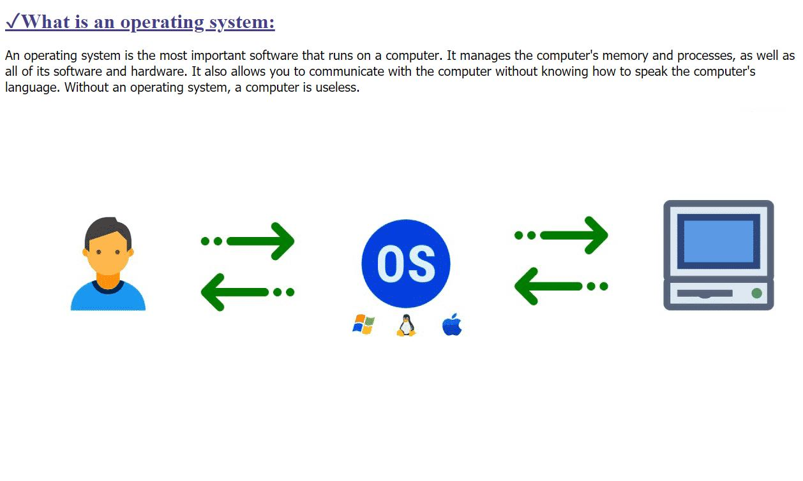  
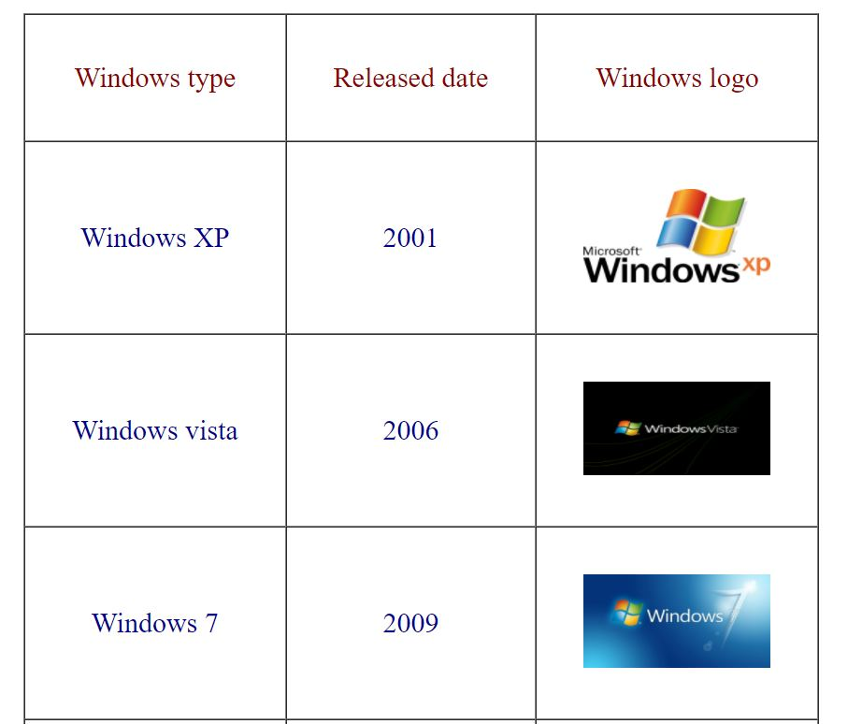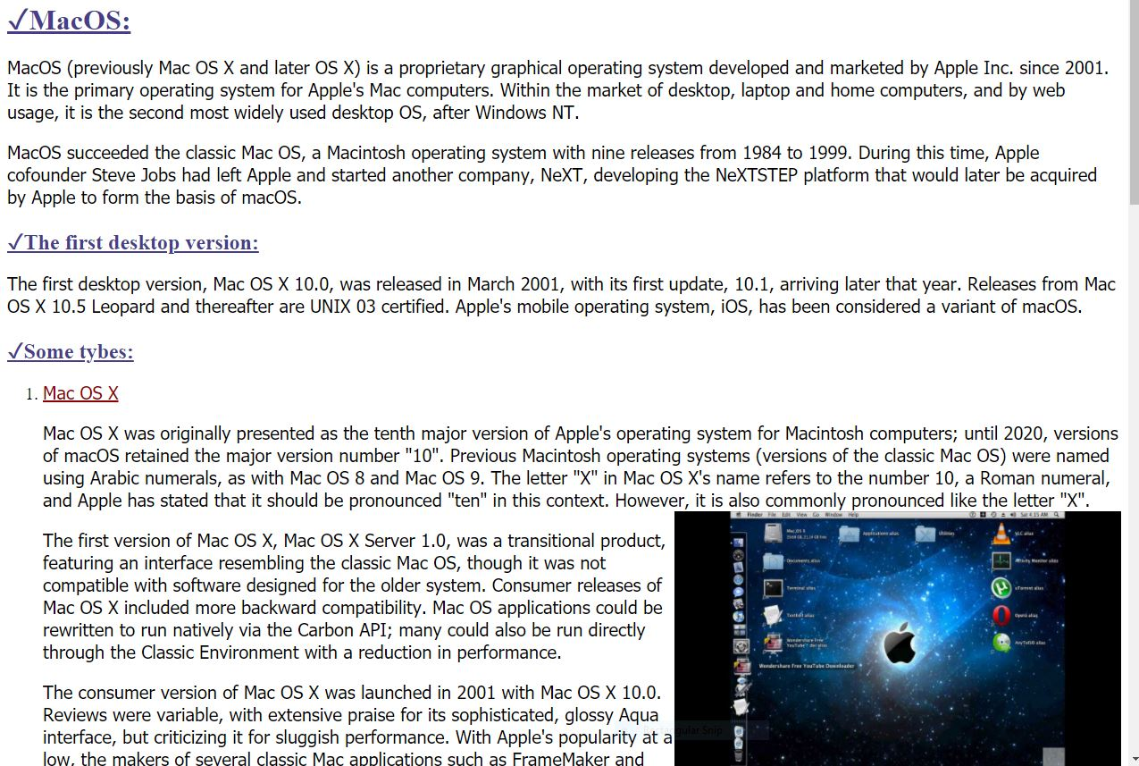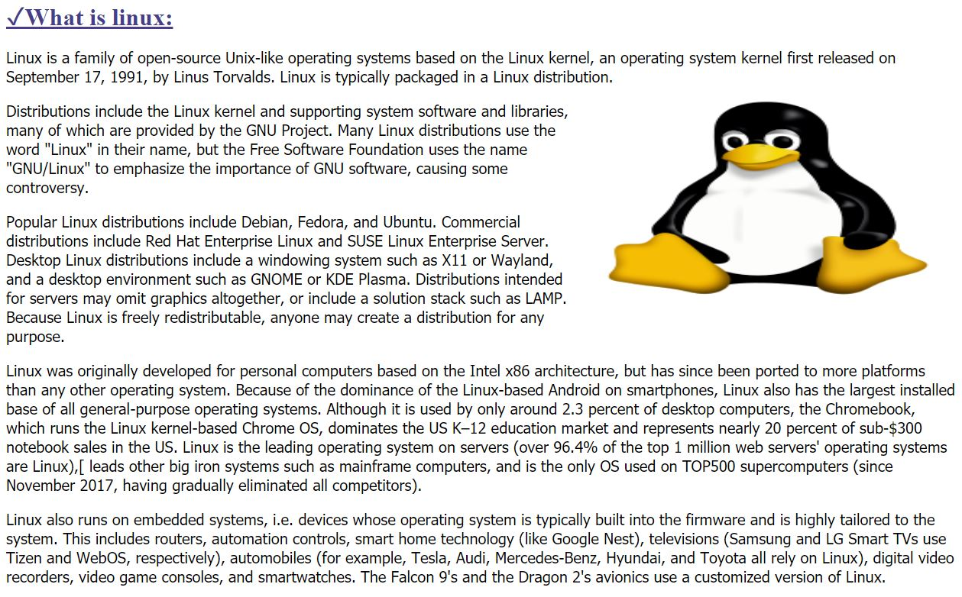***

***Source code:*** 